SIMATS ENGINEERING (SAVEETHA SCHOOL OF ENGINEERING)
Department of Computer Science and Engineering
ASSESSMENT TOOL 1 – MINI APPLICATION DEVELOPMENT
CSA65 – Generative AI and Large Language Models
DETAILED APPLICATION DOCUMENTATION
Student Name: S.DHARANI Reg. No.:192472364
Section / Batch: 2024-2028 Date: 22-08-2026
Questions Selected: 10 and 25
QUESTION 10 – FAQ-BASED GENERATIVE AI CHATBOT
1. AIM
To design and implement an AI-powered FAQ chatbot for a college environment that can answer frequently asked student questions using semantic retrieval and Generative AI. The application should understand direct as well as paraphrased questions, provide relevant answers from a predefined collection of at least 30 FAQs, and safely handle unsupported, random, empty, or unexpected inputs.
2. INTRODUCTION
Students repeatedly ask similar questions about attendance, examinations, library services, assignments, placements, academic procedures, technical support, facilities, certificates, and campus activities. A FAQ-based Generative AI chatbot can provide immediate assistance through a simple web interface. Instead of depending only on exact keyword matching, the proposed system converts questions into semantic embeddings so that questions with different wording but similar meaning can still retrieve the correct FAQ.
The chatbot combines Sentence Transformers for semantic representation, FAISS for similarity search, and Llama 3.2 running through Ollama for natural-language response generation. The retrieved FAQ information is placed into the model prompt so that responses remain grounded in the available knowledge.
3. OBJECTIVES
- Create a college-focused FAQ knowledge base containing 30 or more question-answer pairs.
- Build a user-friendly chatbot interface using Streamlit.
- Convert FAQ questions into semantic vector embeddings using all-MiniLM-L6-v2.
- Use FAISS to efficiently retrieve the most relevant FAQ entries.
- Use Llama 3.2 through Ollama to generate clear and natural responses.
- Support direct and paraphrased student questions.
- Provide fallback responses when information is outside the available FAQ knowledge.
- Handle random, invalid, empty, and unexpected input without crashing.
- Test the application with multiple input cases and document the observed results.
4. PROBLEM STATEMENT
Traditional FAQ systems generally depend on exact keywords or fixed menus. A student may ask the same question using different wording, making simple keyword matching unreliable. The proposed chatbot addresses this limitation through semantic similarity and Generative AI. It retrieves relevant FAQ information and generates a concise response that is easier for students to understand.
5. MODEL / TECHNIQUE SELECTION AND JUSTIFICATION
The selected Generative AI model is Llama 3.2, accessed locally through Ollama. The semantic retrieval technique uses the Sentence Transformer model all-MiniLM-L6-v2. FAISS is used as the vector similarity index.
- Sentence Transformer: Converts FAQ questions and user queries into 384-dimensional semantic embeddings.
- FAISS: Performs similarity search and returns the most relevant FAQ entries.
- Llama 3.2: Generates a natural-language response from the retrieved FAQ context.
- Ollama: Provides local execution of the language model.
- Streamlit: Provides the interactive web interface.
This architecture is appropriate because semantic retrieval improves paraphrase handling, while the language model improves response readability. The fallback threshold also reduces the risk of producing unsupported answers.
6. SYSTEM REQUIREMENTS
Hardware Requirements
- Laptop/desktop computer
- Adequate RAM and storage for the local LLM and Python environment
- Stable system environment for running Streamlit and Ollama
Software Requirements
- Python 3.x
- Visual Studio Code
- Streamlit
- Sentence Transformers
- FAISS CPU
- Ollama
- Llama 3.2
7. KNOWLEDGE BASE
The chatbot uses 35 FAQ entries covering common college-related topics. The entries include working hours, attendance, leave, examination timetable, hall tickets, internal assessment, syllabus, assignments, faculty contact, computer laboratory rules, library working hours, book borrowing and renewal, campus Wi-Fi, password reset, certificates, scholarships, placements, interviews, technical events, college events, technical problems, academic support, department information, student ID, course registration, and related student services.
- SYSTEM ARCHITECTURE
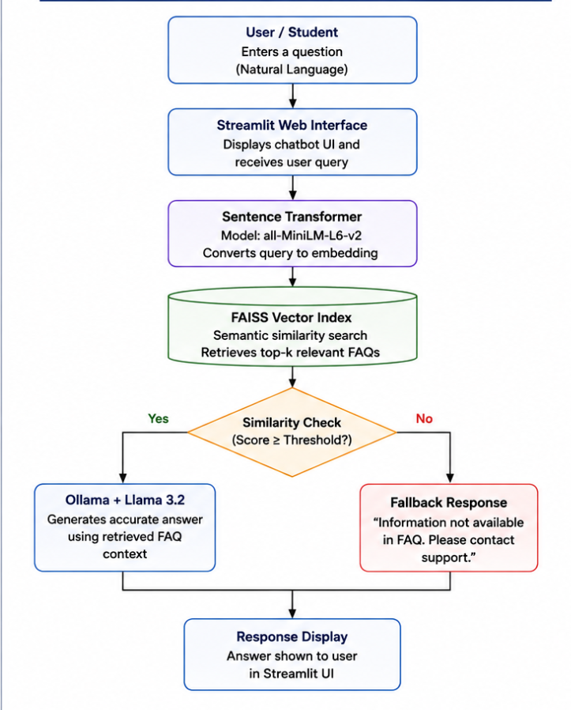
At application startup, the FAQ questions are embedded and stored in a FAISS index. For each new user query, a query embedding is created and compared with the stored embeddings. The top three matching FAQs are retrieved. If the best similarity score is below the configured threshold, a safe fallback response is returned. Otherwise, the retrieved information is provided to Llama 3.2 as context.

9. DETAILED PROCEDURE
1. Create the Question 10 project folder inside AT1.
2. Create faq_data.py and store at least 30 FAQ question-answer pairs.
3. Create chatbot.py for embedding, retrieval, fallback logic, and LLM generation.
4. Create app.py for the Streamlit interface.
5. Create and activate a Python virtual environment.
6. Install Streamlit, Sentence Transformers, FAISS CPU, and Ollama Python packages.
7. Ensure Ollama is installed and the Llama 3.2 model is available locally.
8. Load the FAQ questions into the Sentence Transformer model.
9. Create normalized embeddings and add them to the FAISS index.
10. Accept a user query from the Streamlit chat interface.
11. Generate a semantic embedding for the user query.
12. Retrieve the top three matching FAQ entries using FAISS.
13. Check the best similarity score against the fallback threshold.
14. If relevant, send the retrieved context and question to Llama 3.2.
15. Display the generated answer and maintain chat history.
16. Test direct, paraphrased, unrelated, and random questions.
10. ALGORITHM / WORKFLOW
- Start the application.
- Load FAQ data.
- Generate FAQ embeddings.
- Build the FAISS vector index.
- Accept a student query.
- Generate the query embedding.
- Search for the top matching FAQs.
- If similarity is below the threshold, display a fallback response.
- Otherwise construct the grounded prompt.
- Send the prompt to Llama 3.2.
- Display the generated answer.
- Repeat until the user ends the session.
11. TESTING AND OBSERVED RESULTS
Test | Input | Purpose | Observed Result
1 | How can I check my attendance? | Direct FAQ | Correct attendance response generated.
2 | Where can I see how many classes I attended? | Paraphrase | Correct attendance response generated.
3 | How do I borrow a book from the library? | Library FAQ | Correct library response generated.
4 | What is the capital of France? | Out-of-domain | Safe fallback response displayed.
5 | asdfghjkl | Random input | Safe fallback response displayed.
6 | How can I get my examination hall ticket? | Examination FAQ | Correct hall-ticket response generated.
7 | Where can I get my exam hall ticket? | Paraphrased exam query | Suitable semantic matching demonstrated.
12. ROBUSTNESS AND INVALID INPUT HANDLING
The system was tested with unrelated and meaningless input. For 'What is the capital of France?' and 'asdfghjkl', the chatbot did not invent an answer and instead displayed a fallback message. This demonstrates that the similarity threshold provides a basic guard against unsupported topics. The interface also checks for empty input before processing.
13. ADVANTAGES
- Natural conversational interface
- Understands paraphrased questions
- Fast semantic retrieval
- Local LLM execution
- Grounded responses
- Safe fallback handling
- Easy to extend by adding FAQs
- Suitable for college helpdesk use
14. LIMITATIONS
- Answers are limited by the FAQ knowledge base.
- Institutional information must be updated when policies change.
- Local LLM inference may be slower on low-resource computers.
- Similarity thresholds may require tuning.
- The chatbot is not a substitute for official institutional communication.
15. FUTURE ENHANCEMENTS
- Use official college documents with RAG
- Add Tamil and other Indian languages
- Add voice input and speech output
- Add administrator FAQ management
- Add document citation/source display
- Deploy the application for campus-wide access
- Add analytics for frequently asked questions
16. RESULT
The College FAQ Generative AI Chatbot was successfully implemented using Python, Streamlit, Sentence Transformers, FAISS, Ollama, and Llama 3.2. The application successfully answered direct and paraphrased student questions and provided fallback responses for unrelated and random inputs.
17. CONCLUSION
The FAQ-Based Generative AI Chatbot demonstrates an effective application of Generative AI for student support. Semantic retrieval allows the system to recognize questions even when students change the wording, while FAISS provides efficient retrieval of relevant knowledge. Llama 3.2 converts the retrieved information into natural responses. The testing confirms correct behaviour for direct, paraphrased, unrelated, and random inputs. With official documents, multilingual capabilities, voice support, and better source grounding, the system can be extended into a more complete college information assistant.

18. SCREENSHOTS TO INCLUDE
FAQ chatbot home page
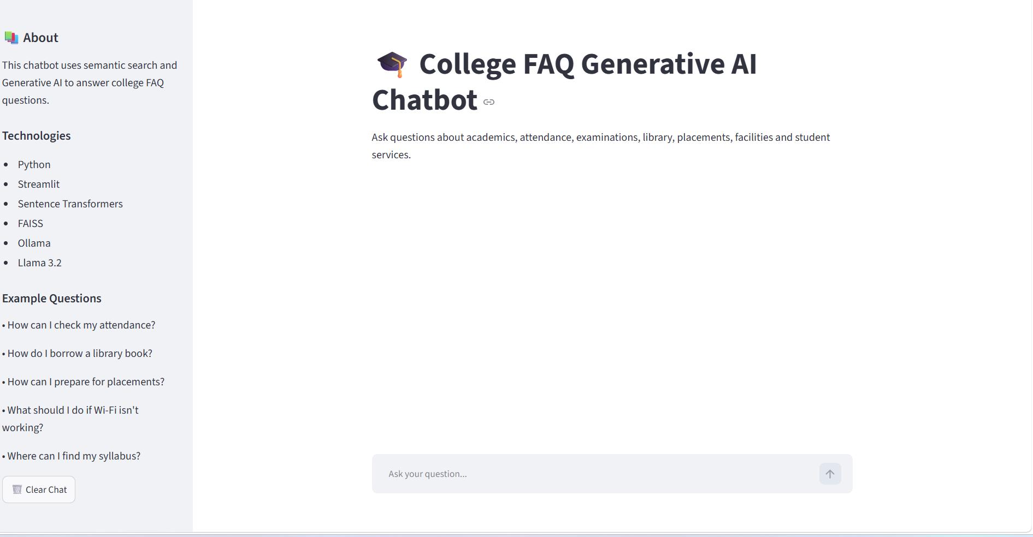
- Direct attendance query and response
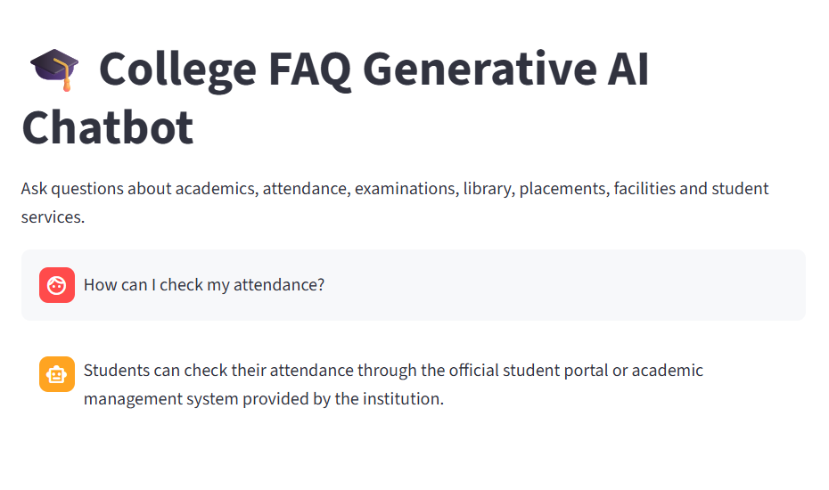

- Paraphrased attendance query and response
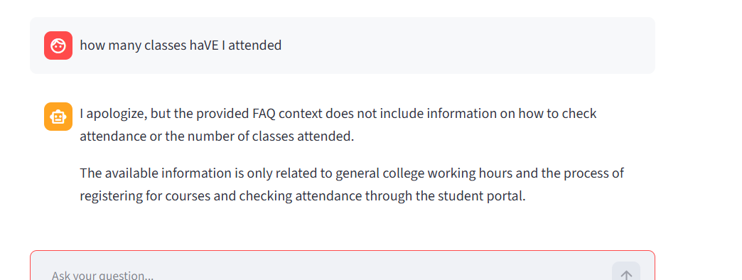
- Library query and response
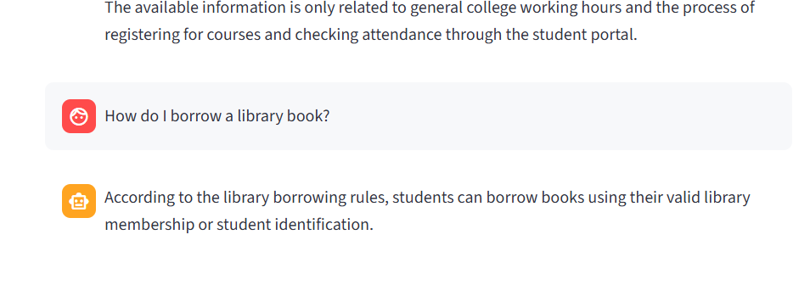
- Out-of-domain fallback
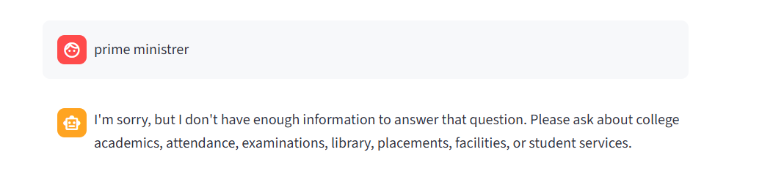

- Random input fallback
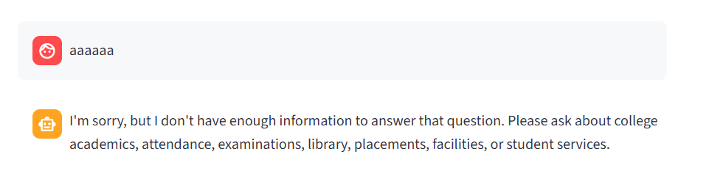
- Examination hall-ticket response
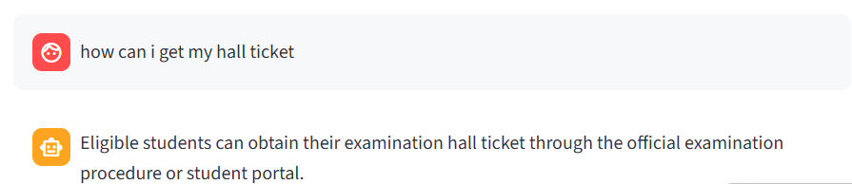
QUESTION 25 – PDF DOCUMENT SUMMARIZER
1. AIM
To design and develop an AI-powered PDF Document Summarizer that accepts a PDF file, extracts its readable text, and generates a concise summary using a Generative AI model. The application provides summary length selection and handles empty, unreadable, invalid, and unexpected PDF inputs through a Streamlit interface.
2. INTRODUCTION
PDF documents are widely used for study notes, research papers, reports, manuals, articles, and institutional documents. Reading a lengthy PDF completely can be time-consuming. The proposed application automates the first stage of document understanding by extracting the text and asking a Generative AI model to produce a concise summary while retaining important information.
The system uses PyPDF for extraction, Streamlit for the interface, and Llama 3.2 through Ollama for summarization. The user can select Short, Medium, or Detailed output according to the intended use.
3. OBJECTIVES
- Allow the user to upload a PDF through a simple web interface.
- Extract text from every readable page of the PDF.
- Detect PDFs that contain no extractable text.
- Generate concise AI summaries using Llama 3.2.
- Provide Short, Medium, and Detailed summary options.
- Prevent very large documents from overwhelming the model by applying input limits.
- Handle PDF reading and AI model errors without crashing.
- Test the application using different document sizes and input conditions.
4. PROBLEM STATEMENT
Long PDF documents contain large amounts of information that may not need to be read in full for an initial understanding. Manual summarization requires time and effort. This application provides an automated solution that extracts document content and produces a shorter version using Generative AI.
5. MODEL / TECHNIQUE SELECTION
Llama 3.2 is selected as the Generative AI summarization model and is accessed locally through Ollama. PyPDF is selected for text extraction because it can read text-based PDF files directly. Streamlit is used for the user interface.
- PyPDF – PDF reading and text extraction.
- Streamlit – web interface and interactive controls.
- Ollama – local LLM runtime.
- Llama 3.2 – abstractive text summarization.
6. SYSTEM REQUIREMENTS
Hardware Requirements
- Laptop/desktop computer
- Adequate RAM and storage for Llama 3.2
- Sufficient processing capability for local inference
Software Requirements
- Python 3.x
- Visual Studio Code
- Streamlit
- PyPDF
- Ollama
- Llama 3.2

7. SYSTEM ARCHITECTURE
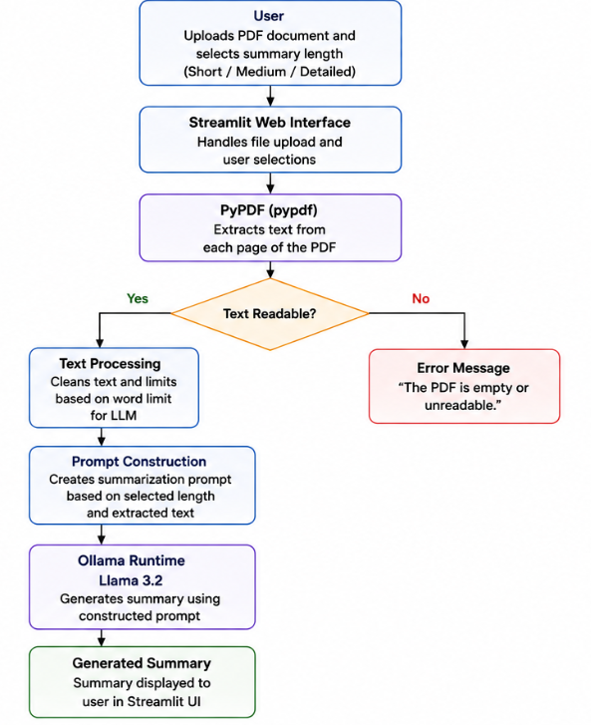
The user first uploads a PDF. PyPDF reads each page and extracts available text. If no readable text is found, the application stops and shows an error. Otherwise, the extracted text is prepared for the model. A prompt specifies the requested summary length and instructs the model not to invent information. Llama 3.2 generates the summary, which is then displayed.
8. DETAILED PROCEDURE
1. Create the Question 25 folder inside AT1.
2. Create pdf_summarizer.py for PDF extraction.
3. Install PyPDF in the active virtual environment.
4. Create app.py for the Streamlit interface.
5. Import Streamlit, the PDF extraction function, and the Ollama chat interface.
6. Create a PDF file uploader accepting only PDF files.
7. Create a summary-length selection box.
8. Extract text from every page after the user clicks Generate Summary.
9. Check whether the extracted content is empty or unreadable.
10. Limit very large input content before sending it to the model.
11. Create a prompt based on the selected Short, Medium, or Detailed mode.
12. Send the prompt to Llama 3.2 through Ollama.
13. Display the generated summary.
14. Catch PDF-reading and model errors and display user-friendly messages.
15. Test valid, empty, unreadable, short, long, and different summary-length cases.
9. ALGORITHM / WORKFLOW
- Start the application.
- Display the PDF uploader.
- Accept the selected PDF.
- Read the PDF pages using PdfReader.
- Extract available text.
- If no readable text exists, display an error.
- Otherwise count the extracted words and prepare the model input.
- Read the selected summary length.
- Construct the summarization prompt.
- Send the prompt to Llama 3.2.
- Display the generated summary.
- If model execution fails, display an error message.
10. SUMMARY LENGTH MODES
- Short: approximately five concise sentences focusing on the main idea.
- Medium: approximately ten sentences containing the major points.
- Detailed: covers the main concepts, important findings, key points, and conclusion.
11. TESTING AND EXPECTED RESULTS
Test | Input | Expected Result | Result
1 | Valid text-based PDF | Text extracted and summary generated | Successful
2 | Short PDF | Concise summary | Successful
3 | Long PDF | Important information summarized | Successful with input limit
4 | Short mode | Brief output | Tested
5 | Medium mode | Moderate output | Tested
6 | Detailed mode | Expanded output | Tested
7 | Empty/unreadable PDF | Error without crash | Handled by extraction check
8 | Invalid PDF | Readable error message | Handled by exception handling
9 | No PDF uploaded | Prompt to upload a file | Handled by interface
12. ERROR HANDLING
The application checks whether a file has been uploaded before processing. The PDF extraction function is enclosed in a try-except block. If the PDF contains no readable text, it returns a clear message instead of passing empty content to the language model. Model failures are also caught and displayed in the Streamlit interface.
13. ADVANTAGES
- Reduces reading time
- Simple upload-based interface
- Generative AI produces readable summaries
- User-controlled summary length
- Handles unreadable documents
- Can be used for study material, reports, articles, and research papers
- Can run Llama locally through Ollama
14. LIMITATIONS
- Scanned image-only PDFs require OCR.
- Very large documents may require chunking and multi-stage summarization.
- Summary quality depends on extracted text quality.
- Local inference can be slower on low-resource systems.
- Important minor details may be omitted by concise summaries.
15. FUTURE ENHANCEMENTS
- Add OCR for scanned PDFs
- Implement chunk-based summarization
- Extract keywords and key points
- Allow DOCX/PPTX/text uploads
- Allow summary download as DOCX or PDF
- Add multilingual summaries
- Add a chatbot for questions about the uploaded PDF
- Display page references for summarized information
16. RESULT
The PDF Document Summarizer was successfully developed as a Streamlit-based Generative AI application. It accepts PDF documents, extracts readable text using PyPDF, and uses Llama 3.2 through Ollama to generate summaries. The application provides different summary lengths and includes handling for empty and unreadable documents.
17. CONCLUSION
The PDF Document Summarizer demonstrates how Large Language Models can automate document understanding. PyPDF provides the document extraction layer, Streamlit provides an accessible interface, and Llama 3.2 provides the Generative AI summarization capability. The system reduces the effort required to understand long documents and can be extended with OCR, chunking, multilingual processing, document download, and question answering. Overall, the application satisfies the main requirements of the PDF Document Summarizer problem and provides a practical engineering use case for Generative AI.

18. SCREENSHOTS TO INCLUDE
PDF Document Summarizer home page
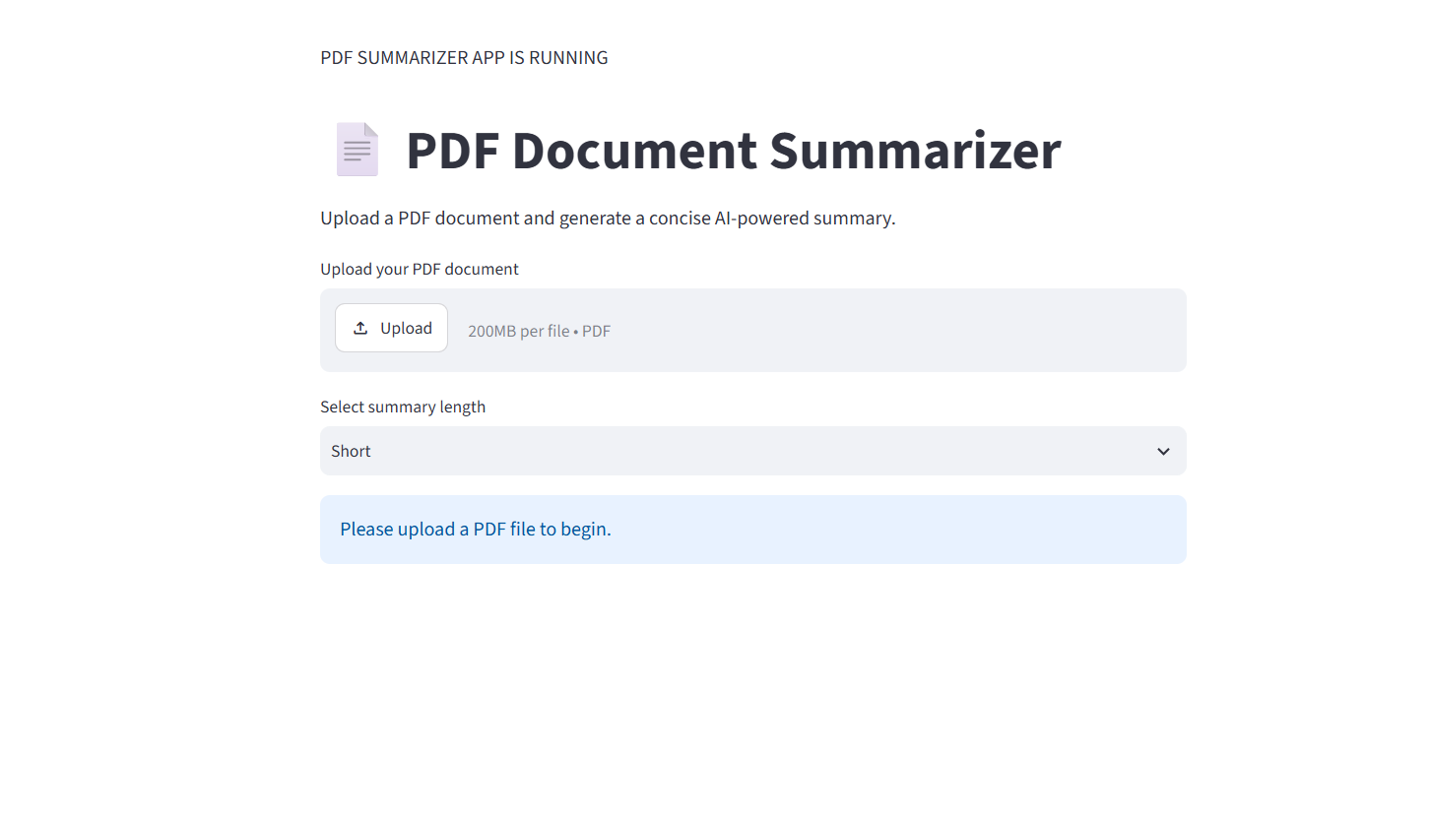
- PDF uploaded successfully
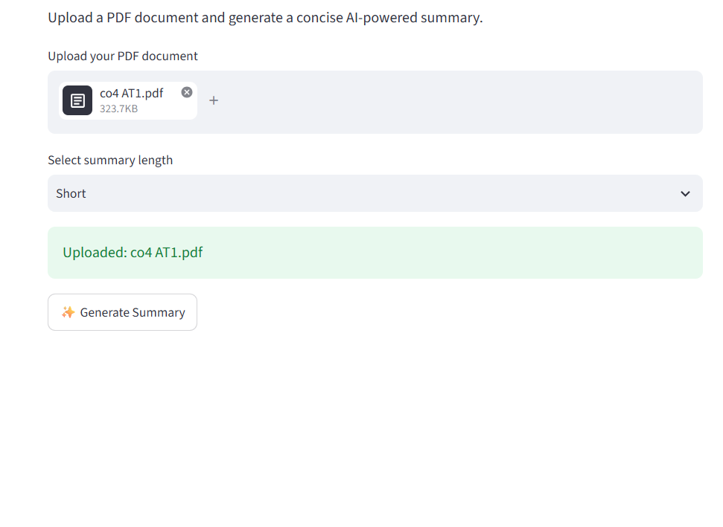
- Summary length selection

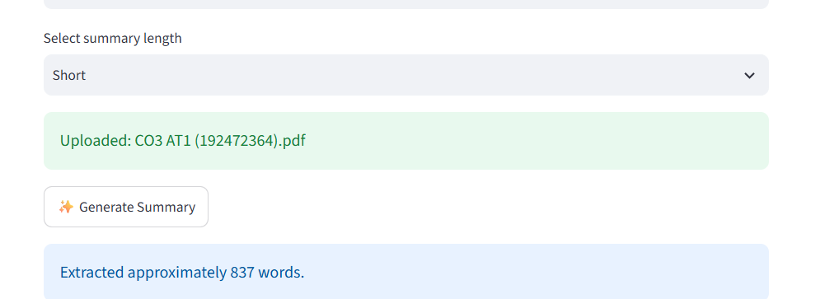

- Extracted word count

- Generated summary
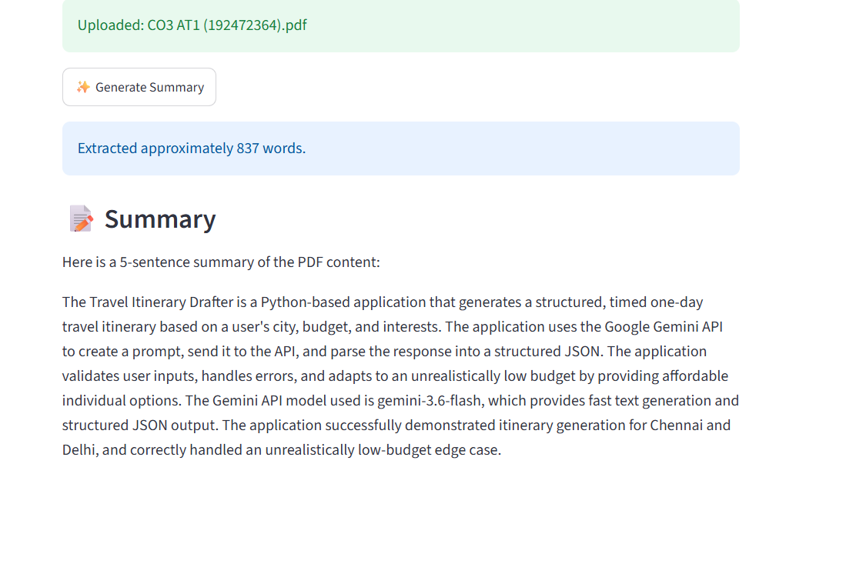
- Empty/unreadable PDF error
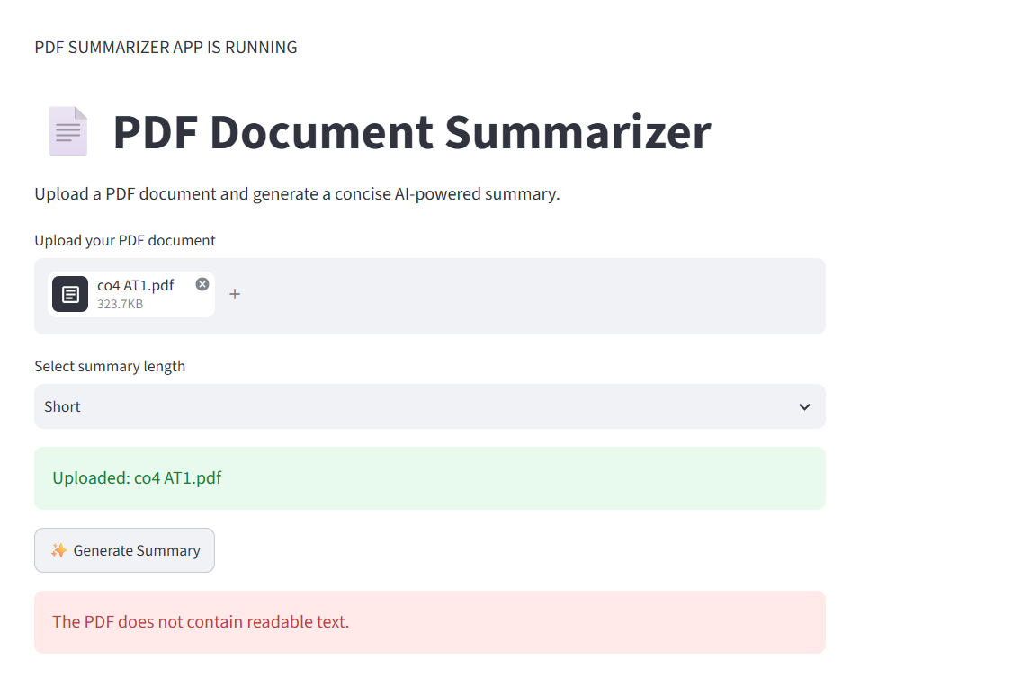
FINAL STUDENT DECLARATION
I certify that the above application development work has been completed for the specified assessment and that the implementation, testing, results, limitations, and future improvements have been documented accurately.
Student Name: S.DHARANI
Register Number: 192472364
Date: 22-08-26

